JIM JUNIOR SCHOOL - KIBUKU

“To Excel Is Our Aim”

Tel (+256)787643047 or (+256)756072716

Email: [schooljimjunior@gmail.com](mailto:schooljimjunior@gmail.com)

**END OF TERM ONE EXAMINATIONS 2023**

**PRIMARY FIVE**

**SOCIAL STUDIES WITH RELIGIOUS EDUCATION**

**DURATION: 2HRS 15 MIN**

**Name ____________________________________________________**

***DO NOT OPEN THIS BOOKLET UNTIL YOU ARE TOLD TO DO SO.***

|  |  |  |
| --- | --- | --- |
| ***FOR EXERMINERS’ USE ONLY*** | | |
| **QN.NO** | **MARKS** | **SIGN** |
| **1 – 10** |  |  |
| **11 – 20** |  |  |
| **21 – 30** |  |  |
| **31 – 40** |  |  |
| **41 – 50** |  |  |
| **51** |  |  |
| **52** |  |  |
| **53** |  |  |
| **54** |  |  |
| **55** |  |  |
| **TOTAL** |  |  |

***Read the following instructions carefully:***

*The paper has two sections* ***A*** *and* ***B***

*Section* ***A,*** *has 40 shot questions (40 marks)*

*Section* ***B****, has 15 questions (60 marks)*

*Answer* ***ALL*** *sections* ***A*** *and* ***B***

*All answers* ***MUST*** *be written using a* ***Blue*** *or* ***Black ball-pointed*** *pen and ink.*

*Un-necessary alternation of work may lead to loss of marks*

*Any handwriting that cannot be easily read may lead to loss of marks.*

*Do* ***Not*** *fill anything in the boxes shown.* ***”FOR EXERMINERS’ USE ONLY”***

**SECTION A**

1. Which country does Uganda boarder to the south?

…………………………………………………………………………………..

1. Mention one element a good map should have.

………………………………………………………………………………….

1. Name any one basic need provided my markets in our community.

………………………………………………………………………………….

1. What is the quickest type of transport used in Uganda?

………………………………………………………………………………….

1. What term is used to mean the natural landform of an area?

………………………………………………………………………………….

1. Give one importance of a school sign post.

………………………………………………………………………………….

1. How is vegetation used in controlling diseases?

………………………………………………………………………………….

1. Which raw material is provided by swamps to potters?

………………………………………………………………………………….

1. Why do the police officers put on uniforms when doing their work?

…………………………………………………………………………………

1. Give one way people protect themselves from rainy weather.

…………………………………………………………………………………

1. How does a nurse promote the health of pupils in a school?

…………………………………………………………………………………

1. Name the bank in Uganda which gives money to commercial banks.

…………………………………………………………………………………

1. Why is Rwanda referred to as a landlocked country?

………………………………………………………………………………….

1. Write K.C.C.A in full.

………………………………………………………………………………….

1. Why do people keep cows at home?

………………………………………………………………………………….

1. Mention the type of rainfall received in hilly areas.

………………………………………………………………………………….

1. In the space below, draw a map symbol of a water swamp.
2. What social service is provided by teachers in our district?

…………………………………………………………………………………

1. Mention any one form of child abuse in the community.

…………………………………………………………………………………

1. What type of wood is got from natural forests?

…………………………………………………………………………………

1. What title is given to the traditional leader of Buganda?

…………………………………………………………………………………

1. Mention one member found in a nuclear family.

…………………………………………………………………………………

1. How were block mountains formed?

…………………………………………………………………………………

1. State one role of a child at home.

…………………………………………………………………………………

1. In which way is land useful to people in a country?

…………………………………………………………………………………

1. Mention the language spoken by people in your community.

…………………………………………………………………………………

1. How is democracy practiced in your school?

…………………………………………………………………………………

1. Name the road sign drawn below.

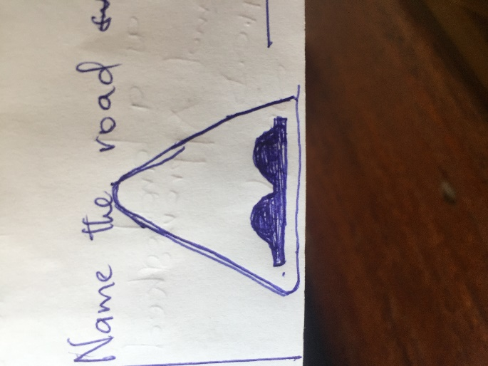 ………………………………………………

1. Name any one group of people who use a compass.

………………………………………………………………………………….

1. Give any one use of lakes to man.

………………………………………………………………………………….

1. What is the main work of the Uganda police?

………………………………………………………………………………….

1. How are nimbus clouds useful to farmers?

………………………………………………………………………………….

1. Name any one modern means of communication.

………………………………………………………………………………….

1. Give the meaning of the term “communication”

………………………………………………………………………………….

1. Mention one benefit of a school to the community.

………………………………………………………………………………….

1. Name the creature that was created in Allah’s image.

………………………………………………………………………………….

1. State one quality of a good Muslim.

………………………………………………………………………………….

1. Name the first wife of Prophet Muhammad.

………………………………………………………………………………….

1. What day is marked to celebrate the end of Ramadhan?

………………………………………………………………………………….

1. Why do Muslims pay zakat?

………………………………………………………………………………….

**SECTION B**

1. a) Give two responsibilities of a child at home.

……………………………………………………………………………………………………………………………………………………………………

b) Mention one problem faced by children who don’t fulfil their responsibilities.

………………………………………………………………………………….

c) Name the local council I official in charge of children affairs.

………………………………………………………………………………….

1. a) Mention two regions in Uganda.

……………………………………………………………………………………………………………………………………………………………………

b) Mention any two district found in the Eastern region.

……………………………………………………………………………………………………………………………………………………………………

1. a) Give the meaning of the following terms.
2. A map: ………………………………………………………………

………………………………………………………………………..

1. A picture: ……………………………………………………………………………………………………………………………………………………

b) Draw a map of a water pot in the space provided below.

c) How important is a scale to a map reader?

………………………………………………………………………………….

1. a) Name the three colours found on the Uganda flag.

………………………………………………………………………………………………………………………………………………………………………………………………………………………………………………………

b) Which colour represents sunshine?

…………………………………………………………………………………

1. a) What are economic activities?

…………………………………………………………………………………

b) Give any two economic activities carried out by people in your district.

……………………………………………………………………………………………………………………………………………………………………

c) What type of transport is commonly used by the people travelling to Kalangala district?

…………………………………………………………………………………

1. a) Write the abbreviations below in full.
2. R.D.C …………………………………………………………………..
3. C.A.O …………………………………………………………………

b) Mention any two ways how people become leaders in our country

……………………………………………………………………………………………………………………………………………………………………

1. Study the map of Uganda below and answer questions that follow correctly.

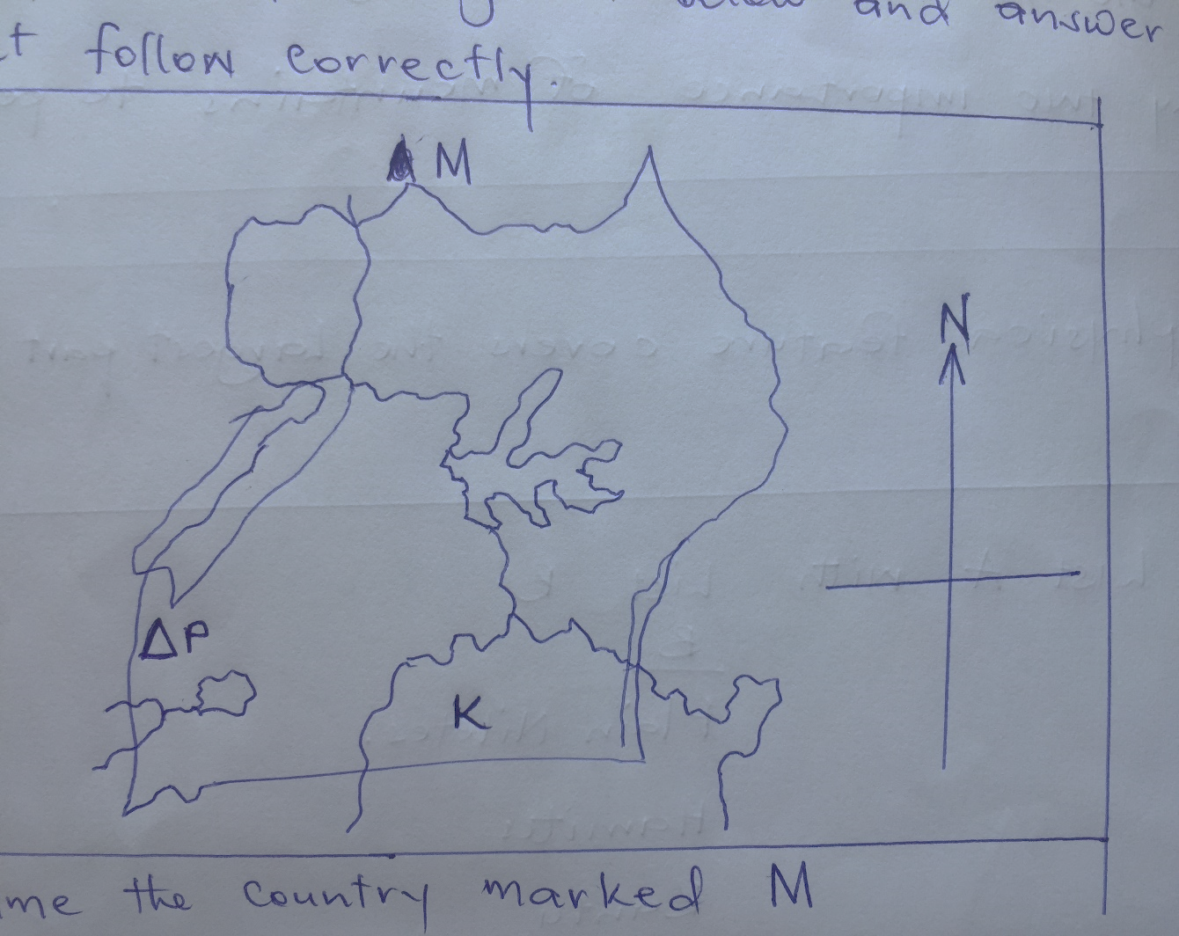

1. Name the country marked M.

……………………………………………………………………………….

1. Use a pencil and a ruler to draw the line of latitude marked 00 on the map above.
2. Mention the animal used as a mean of transport on mountain marked P.

………………………………………………………………………………

1. What type of rainfall is received around lake marked K?

……………………………………………………………………………….

1. a) What is weather?

………………………………………………………………………………….

b) Name the type of weather where the item below is commonly used.



……………………………………………..

c) Mention any two weather instruments you know.

…………………………………………………………………………………………………………………………………………………………………….

1. a) Name one volcanic mountain in Uganda.

………………………………………………………………………………….

b) Give any two importance of mountains to people.

………………………………………………………………………………….

………………………………………………………………………………….

c) Which physical feature covers the largest part of Uganda?

…………………………………………………………………………………

1. Match List A with List B

**List A**

Basoga

Iteso

Acholi

Bahima

**List B**

Plain Nilotes

Hamites

Bantu

River Lake Nilotes

Basoga ……………………………………………………………………….

Iteso ………………………………………………………………………….

Acholi ……………………………………………………………………….

Bahima ………………………………………………………………………

1. Mention any four months of the Islamic calendar.

…………………………………… ……………………………….

…………………………………… ……………………………….

1. List down the four holy books in Islam.

…………………………………… ………………………………..

…………………………………….. …………………………………

1. Write down four body parts which should not be shown by a Muslim.

……………………………………. ………………………………….

……………………………………. ………………………………….

1. On which day do Muslims go for congregational prayer?

………………………………………………………………………………….

b) How many times do Muslims pray a day?

………………………………………………………………………………….

c) Give two reasons why Muslims pray.

………………………………………………………………………………..

………………………………………………………………………………..

1. In which four ways can a Muslim show love to his / her neighbours?
2. ……………………………………………………………………………
3. ……………………………………………………………………………
4. ……………………………………………………………………………
5. ……………………………………………………………………………